Append Queries
Steps
- In Power BI Desktop, go to Home → Transform data.
- In Power Query, select Home → Append Queries.
- Choose:
  - Two tables → select the two tables, or
  - Three or more tables → select all tables you want to combine.
- Click OK.
- Power Query will stack the rows from the tables into one table.
- Click Close & Apply.


Table 1: T1
.
.

Table 2: T2

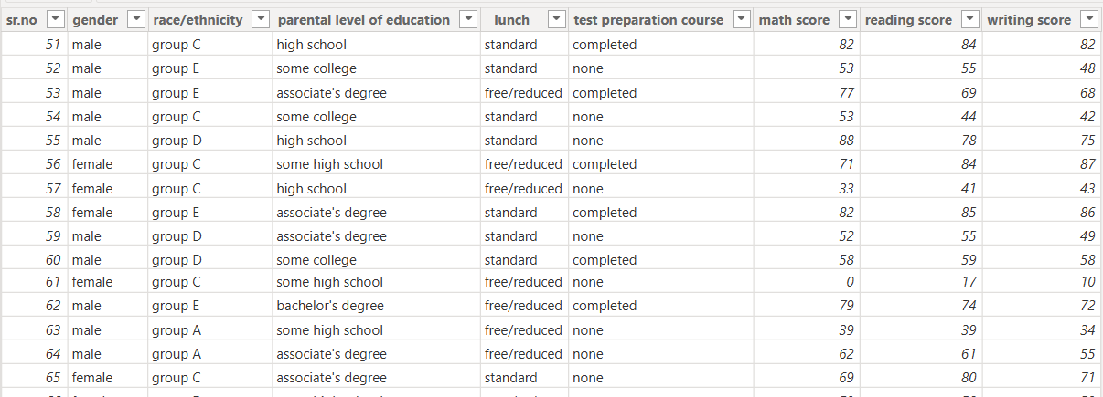
.
.
.



Then Append T1 And T2: Create Table 3-
.
.
.

Table 3 gives Row 1 to 100 before append

Append is for adding rows. If you want to add columns by matching a key such as CustomerID, you want Merge Queries instead.

